Market Feasibility Study

2.1 Market Survey

2.1.1 Survey

We need to properly distribute the survey among many segments with respect to their educational, financial, societal levels, age and gender. This is crucial to end up with a survey that represents the population accurately. This would need ample time and resources which requires us to hire a surveyor association for optimal results.

2.1.2 Competitors

A new set of smart glasses from Envision can help blind people read. The glasses, which were built on the enterprise edition of Google Glass, rely heavily on artificial intelligence to help people see and understand their surroundings.

Envision isn’t the only company developing apps and hardware to help blind people see. Google’s Lookout app can help people identify food labels, as well as find objects in a room. Like Envision, it can also scan documents, money, and other things. As [CNET](https://www.cnet.com/tech/mobile/envision-glasses-for-the-blind-can-read-documents-scan-faces-and-help-navigate/) mentions, Be My Eyes is also another app that can help. It connects visually impaired users with sighted volunteers. The volunteers then help the user get around via a live chat function.

[Microsoft Soundscape](https://www.microsoft.com/en-us/research/product/soundscape/) is an application built by the [Enable Group](https://www.microsoft.com/en-us/research/group/enable/) in Microsoft Research. The Soundscape app is breaking barriers and opening up new possibilities for visually impaired people with voice-based navigation. Anyone can take this app on the go and enjoy the independence that comes with being able to explore the world on their own terms. Using a stereo headset such as AirPods, users can traverse new and old environments guided by a map delivered in 3D sound.

There is also Facing emotions created by Huawei which identifies the 7 basic human emotions of irritation, contempt, sorrow, fear, anger, surprise and happiness. The app then turns those emotions into unique sounds to help the visually impaired learn how the person on the other side of the conversation is feeling.

2.2 Feasibility Study

2.2.1 Market Analysis

|  |  |
| --- | --- |
| ▪ Market Outline: **Our Market** | Mobile applications for helping people with visual loss in their daily lives such as shopping, dressing or moving around the city |
| **Target Audience** | People with visual impairment |
| **Competitors** | * Google(lookout) * Envision * Microsoft soundscape * Facing Emotions |
| **Customer Wants** | * Navigate their homes easily * Chat with people and know their emotions * Identify the currency or amount they are holding * Pick matching clothes easily |
| **Services Offered by Competitors** | * Navigation * Scan documents, money * Identify food labels |
| **Services Offered to Customers** | * Chatbot * Navigator * Document scan * Read handwritten articles and documents * Emotion detector |

Competitive Study

|  |  |  |  |  |
| --- | --- | --- | --- | --- |
| Features/app | Lookout | Envision | Soundscape | Facing Emotions |
| Chatbot |  |  |  |  |
| Navigator | done |  | done |  |
| Document scan | done | Done |  |  |
| Emotion detector |  | Done |  | Done |
| Currency detector | Done |  |  |  |
| Food labels | Done |  |  |  |

Market Research

In order to understand the market clearly, we must systematically gather and analyse the needed data. As shown in the below figure, visual impairment is problem that faces approximately 36 million people.

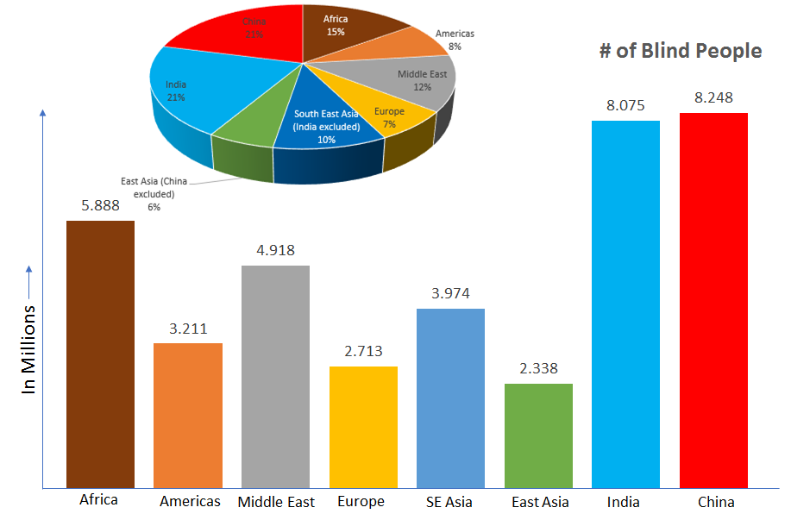

* The number of blind people across the world is set to triple within the next four decades, researchers suggest.
* Writing in [Lancet Global Health](http://www.thelancet.com/journals/langlo/article/PIIS2214-109X(17)30293-0/fulltext?elsca1=tlpr), they predict cases will rise from 36 million to 115 million by 2050, if treatment is not improved by better funding.
* While Analysis of data from 188 countries suggests there are more than 200 million people with moderate to severe vision impairment.
* That figure is expected to rise to more than 550 million by 2050.

Cases in Egypt

According to the World Health Organization W-H-O, there are more than 2.2 million people with visual impairment in Egypt 900,000 of which are totally blind.

Khalid Karem, a graduate student in The Faculty of Languages at Ein Shams University specialized in English and Hebrew language who was born with full blindness said: “Inaccessibility of streets is another hardship that visually impaired people have to cope with. Sidewalks and pavements that are supposed to help the blind person walk safely are instead occupied by the street sellers, shops and parking cars. Visually disabled people who decide to walk alone in the streets of Cairo put their lives at risk. Karem, recalls his experience walking in Cairo.”

SWOT analysis

|  |  |
| --- | --- |
| **Strengths** | **Weaknesses** |
| * AI chatbot * 24/7 availability * Privacy * Internet access not needed(maps can be saved offline) * Understand other people better through knowing their face emotions | * AI functions are not 100% accurate hence can identify wrong currencies or emotions * Lack of empathetic human care * Expertise need |
| **Opportunities** | **Threats** |
| * Improving humans’ life * Convenience * Spreading awareness | * Risk of over depending on technology * Data security |

The SWOT analysis shows that we have great strengths that could contribute to great opportunities. However, we must be careful to avoid probable threats and overcome our weaknesses. The several technologies offered by our application like AI chat bot will not only spread awareness but also it will compensate the empathetic human care. Also, offering privacy as a key feature in our application will contribute to anonymity and overcome data security concerns. Moreover, the idea of being able to use the features 24/7 will help make the user to be more independent in their lives and avoid the feelings of always needing to depend on others to perform daily life tasks

2.3.2 Technical Analysis

The technical analysis is one of the most important dimensions of the feasibility study. We will analyze the project in order to see if it is technically feasible or not and to make the best out of the available technology and human resources or decide on an alternative. There are a lot of factors that we will discuss.

2.3.2.1 Engineering and Technology

▪ document scan → NLP

▪ Chat Bot → NLP

▪ mobile application → Flutter